**Running servers easily**

* Register to Docker hub <https://hub.docker.com>
* We can play with docker <https://labs.play-with-docker.com/>
* Login into playground and create a new instance

docker container run -d -P <image-name>:<tag-name>

docker container run -d -P jenkins/jenkins:lts-jdk11

docker container ls

* We can run the sonarqube by executing the following command

docker run -d --name sonarqube -e SONAR_ES_BOOTSTRAP_CHECKS_DISABLE=true -p 9000:9000 sonarqube:latest

**Installing Docker on Ubuntu**

* AWS:
  + Create a security group with all ports opened (not a secure approach but its okay for lab setup)
  + Create an ec2 instance with ubuntu 20.04
  + login into ec2 instance and execute the following commands  
    “`  
    curl -fsSL <https://get.docker.com> -o get-docker.sh  
    sh get-docker.sh  
    sudo usermod -aG docker ubuntu  
    exit

**relogin** docker info  
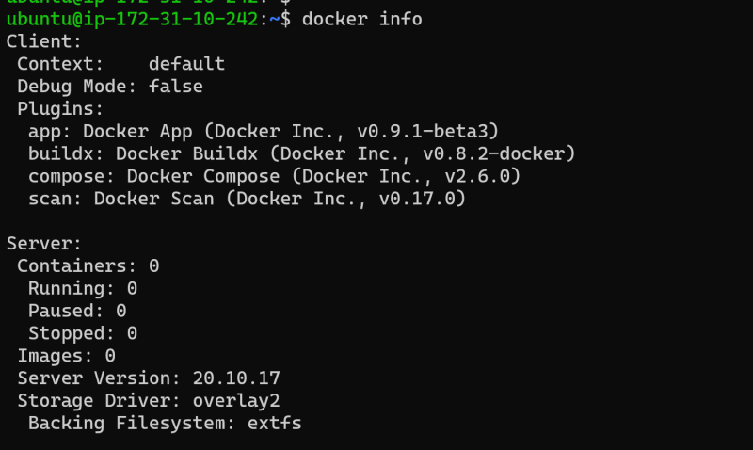

* Now run sonar qube using following command docker run -d –name sonarqube -e SONAR_ES_BOOTSTRAP_CHECKS_DISABLE=true -p 9000:9000 sonarqube:latest* Navigate to sonar qube using<http://publicip:9000>`

* Azure:
  + Create a ubuntu vm
  + login into vm after opening all ports in nsg  
    “`  
    curl -fsSL <https://get.docker.com> -o get-docker.sh  
    sh get-docker.sh  
    sudo usermod -aG docker ubuntu  
    exit

**relogin**

docker info  


* Now run sonar qube using following command docker run -d –name sonarqube -e SONAR_ES_BOOTSTRAP_CHECKS_DISABLE=true -p 9000:9000 sonarqube:latest* Navigate to sonar qube using<http://publicip:9000>`